**Property Indication**

1. **Property Information:**

|  |  |
| --- | --- |
| **Property Address:** | Phum Dey Thmey, Sangkat Phnom Penh Thmey, Khan Sen Sok. |
| **No. of Storey:** | N/A |
| **Land Size** | 549 sqm |
| **Building Size:** | N/A |
| **Title Deed No:** | 12070508-0451 |
| **Inspection person** | Mr. Sok Ratanak and Miss. Taing Chandavy |
| **Inspection Date** | 13-07-2015 |

1. **Maps:**

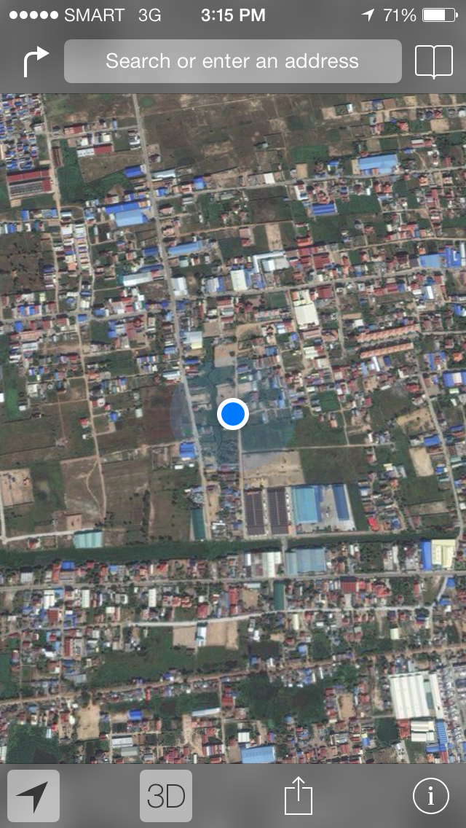

1. 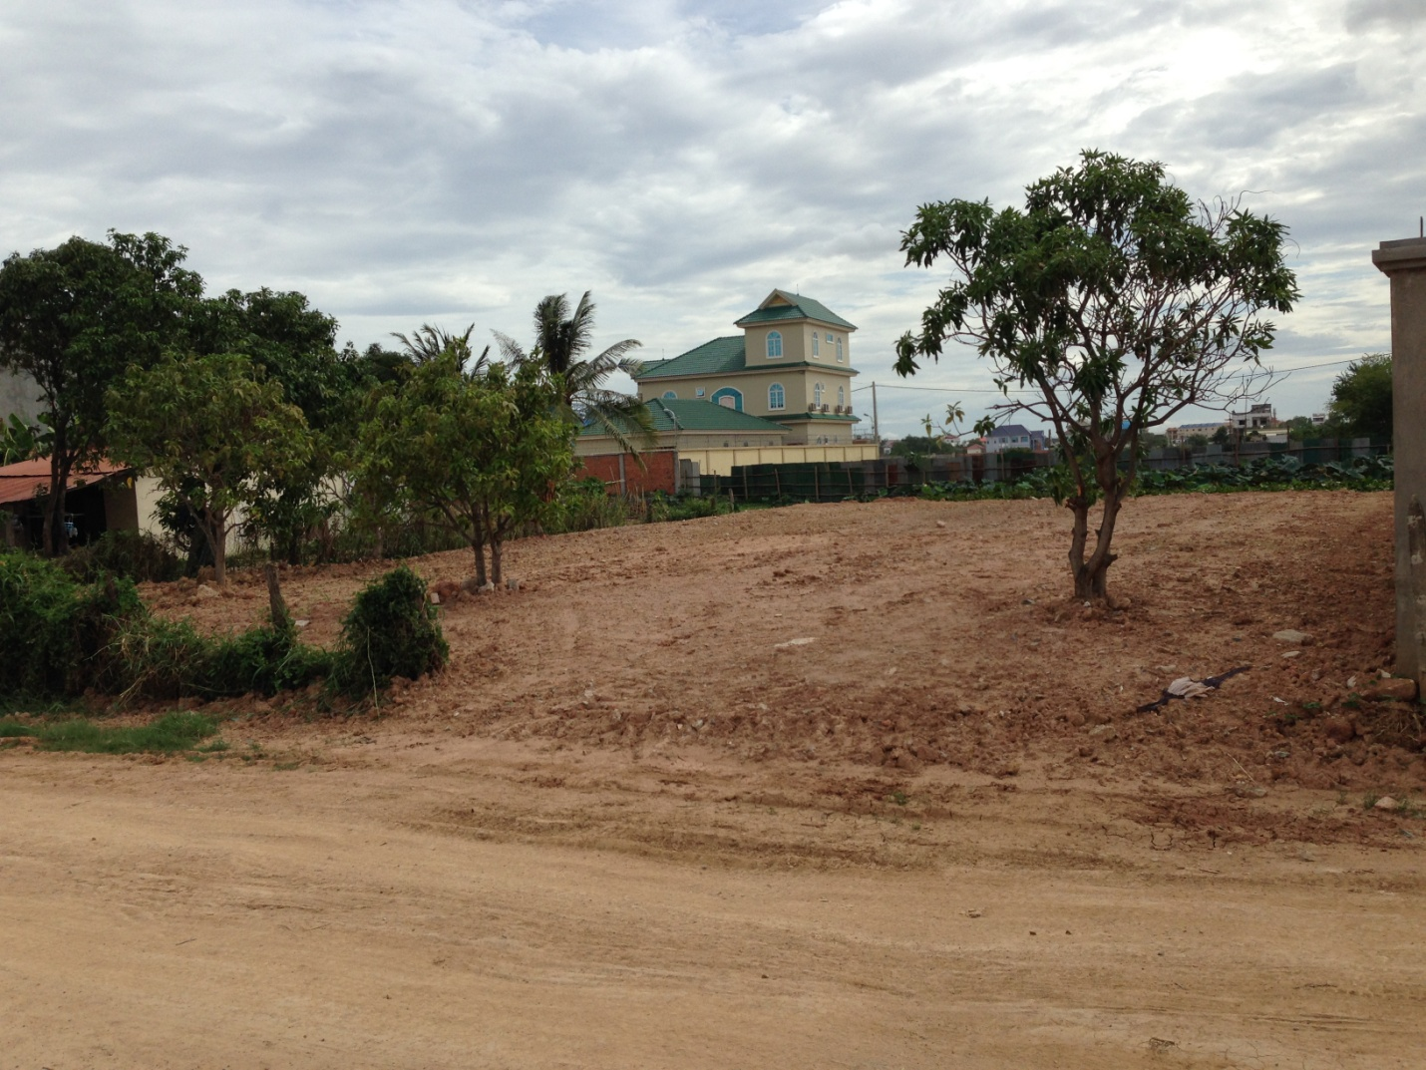**Property Photo:**

**Property to be charge**

